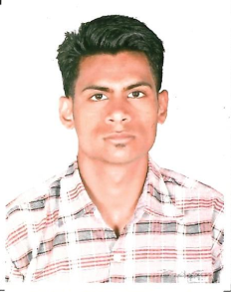
Akash Singhai
Fitter Instuctor(Theory)

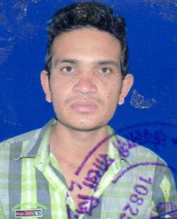
Durgesh Rajput
Electrical Instuctor(Practical)

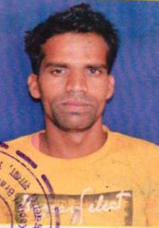
Mitendra Jhariya
Fitter Instuctor(Practical)

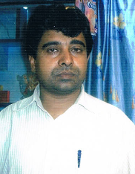
Nishant Jain
Electrical Instuctor(Theory)

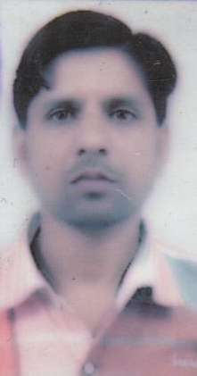
Om Prakash Rajpoot
Fitter Instuctor(Practical)

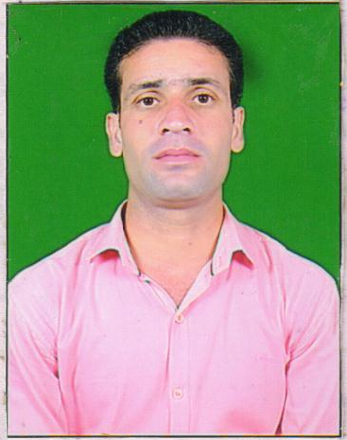
Vinod Patle
Electrical Instuctor(Practical)

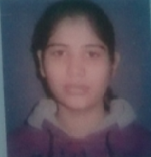
Anjali Jain
Principal


Sourabh Jain
Computer Instructor

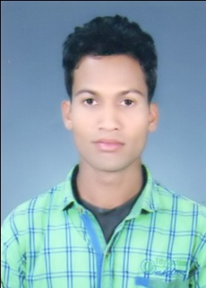
Satendra Kartikey
Clerk


Anamika Jain
Accountant

